Introduction

Oil has the benefit of never wearing out – it can be cleaned and reused many times. In other words – it should be recycled. The [process for recycling waste oil](http://www.greenlivingtips.com/articles/recycling-used-engine-oil.html) includes water extraction, filtering, de-asphalting, and distillation. The oil can then be reused for use in motorized equipment, turned into hydraulic oil, or used to make plastics. Another way to use waste oil efficiently is as heating fuel. Waste oil heat production can heat water or be a source of warmth in colder months. [Waste oil heaters](https://www.energylogic.com/waste-oil-heaters/) and [boilers](https://www.energylogic.com/waste-oil-boilers/) use waste oil as a fuel source for heat, and they provide quick heat and easy cleanup. As a result, it is necessary to address every available source of energy in order to ensure that the field of oil recycling receives more attention. The importance of using furnaces in attempting to accomplish this task cannot be overstated. A furnace is an enclosed structure in which materials can be heated to very high temperatures to obtain the desired output. A waste oil-fired furnace is being designed as part of this project with the primary purpose of ensuring high efficiency by successfully limiting heat losses and maximizing heat generation.

Used Oil-fired furnaces have been around for a long time, but little has been done to ensure that these furnaces operate with the highest efficiency possible. Nonetheless, most of these furnaces are operated manually, putting the operators at risk in case of explosions or toxic gas exposure. Furthermore, these furnaces we just able operate at specific temperatures with no room for adjustment if need be. In recent years, there have been numerous attempts to address the issue, but these efforts have not yielded any significant results.

The aim of this project aims to design the used oil furnace based on the Mechatronic approach. It tends to address issues such as automatic controlled flow of oil, automatic ignition, automatic pressurizing of oil, oil preheating, automatic temperature control, and finally material selection in furnace design.

Conventional Oil Furnaces

Burner

Conventional designs of the burner do not gather for its maintainability. The burner is designed as a single solid attached to the nozzle. Since most furnaces operate at temperatures more than 18000C, such burners burn out and become non-functional after some few operations. Due to the solid design of such furnaces, replacements of such parts require overhauling. The choice of material plays a role in the frequency of maintenance.

Nozzle

Most designs use separate nozzles for pressurized air and oil. Such a design has proven to be inefficient since smoke emissions are frequently witnessed. It also introduces complexity in the design since the pressurized air nozzle has to be placed as the measured distance from the pressurized oil nozzle and this might not always be accurate.

Ignition

Ignition for conventional oil furnaces employs a flammable burner mounted on an insulator or even soaked in a highly flammable petroleum fuel. This method is unsafe since its control is limited. The use of highly flammable petroleum fuel for ignition also makes it expensive and borderline dangerous.

Emission

Combustion of oil in a good proportion of oxygen produces carbon dioxide. During oxygen deficiencies, carbon monoxide is released. If not detected and controlled such gases can be catastrophic. Since such emissions are invisible, conventional designs of this type of furnace do not gather for such hazards.

Oil Consumption

Conventional designs are based on the workability of the design. Its efficiency is rather given very minimal attention. The use of separate nozzles for the pressurized oil and air undermines the efficiency of the design. As such, the consumption of oil is rather higher.

Assembly

Processes

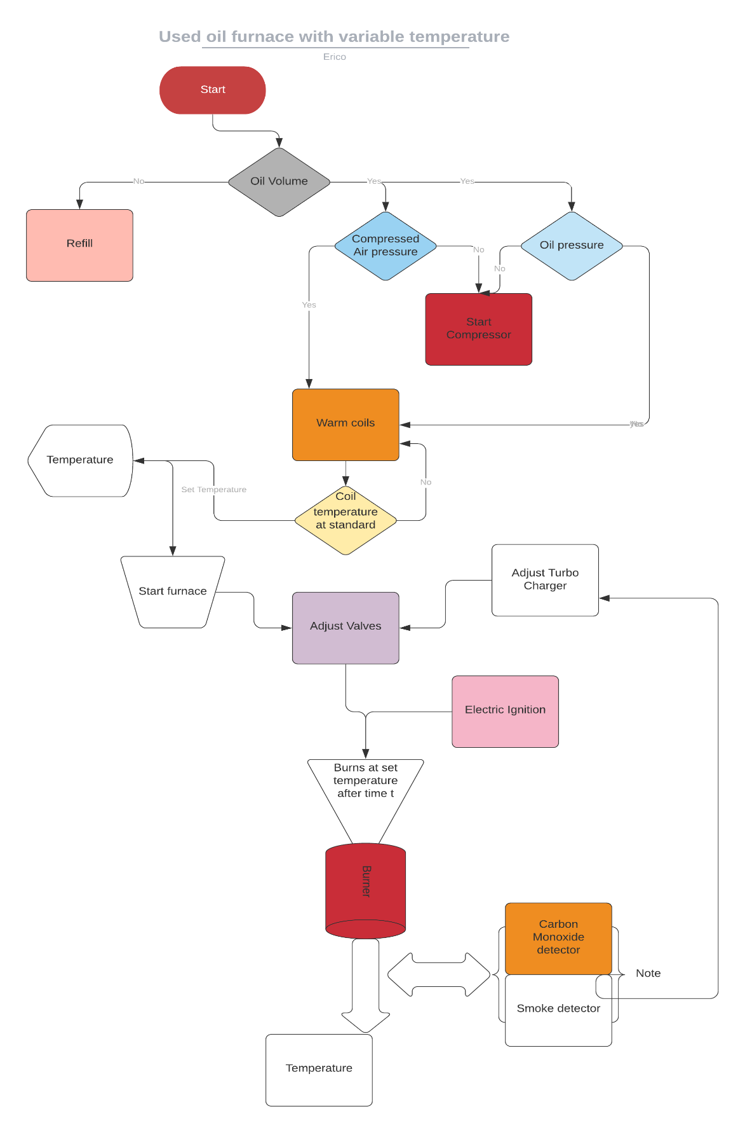

On powering on, the system automatically checks the volume of oil in the oil storage tank. This is determined by a **level sensor** installed in the tank. Depending on the volume, the system decides whether to refill the tank from an even bigger tank or raise an alert for a refill. If the required volume of oil is available the system then checks the pressure of oil in the tank and the pressure of compressed air in the air storage tank using **pressure sensors**. In any case, the pressure is below the required, the system automatically turns on the compressor to refill the two containers to the required pressure. Once the pressure requirements in the two containers are met, the system automatically switches off the compressors and starts warming the **coils** on the path of the pressurized oil to the injector. The compressor is turned on, and off to maintain constant pressure in the tank.

Once the coils warm to a standard base temperature, the user is then prompted on the interface to enter the **furnace operation temperature**. From this input, the system adjusts both the air and pressurized oil valves using **a stepper motor** connected to each of the valves. A supercharger is connected to the compressed air flow pipe through a **pneumatic motor** and a **pneumaticgear system** to magnify the speed of the airflow. It is also adjusted in proportion to the pressure along the airflow pipe. This is to ensure the maximum supply of oxygen to the combustion chamber and to reduce emissions.

The pressurized oil and compressed air mix evenly in the **coaxial swirl injector**. The injector is designed in such a way that it ensures oil is atomized and mixes evenly with enough amounts of oxygen. Once the flow of oil and pressurized air is steady, an **electric igniter** descends to the tip of the nozzle and sparks to ignite the mixture. It then retracts to a safer height since its material cannot withstand furnace temperatures.

The mixture burns at the burner. With the correct choice of material, the burner can achieve up to **18340C.** Around the burner are the **smoke detector**, **carbon monoxide detector, and a thermal gun**. These sensors continuously check the smoke, levels of carbon monoxide, and temperature at the output, and this information is transferred to the ECU which adjusts the supercharger, oil, and air valves to correct the values.

Cylinder modeling

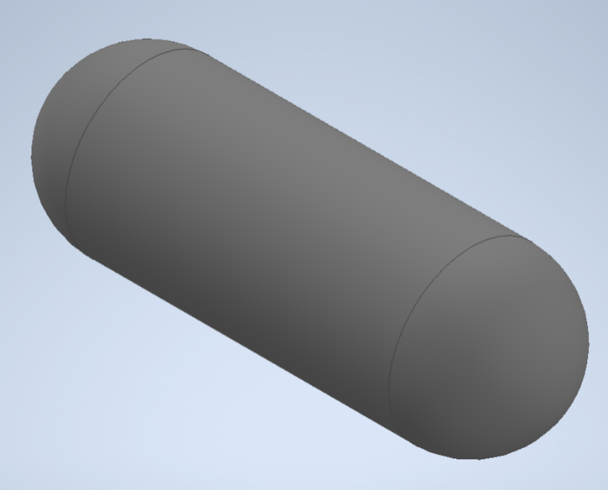

Fig 1.1 Cylinder

Thickness

The cylinder is designed to have to have the following dimensions:

Length: 3m

Internal Diameter: 800mm

The thickness of the cylinder has to be chosen carefully to achieve a recommended factor of safety for pressure vessels of between 3 and 6. To determine that, Clavarino’s equation is preferred to Lame’s equation since the cylinder is closed at both ends as shown in *figure 1.1*.

Clavarinos Equation

Clavarinos equation is used to determine the wall thickness of a cylinder. This is equation is applicable to cylinders with closed ends made of ductile materials. It is based on maximum principal strain theory.



*Fig 1.2 Clavarinos Formula*

Where:

P is the internal pressure, N/m2

D is the internal diameter, m

S is the allowable tensile stress, N/m2

t is the thickness of the material shell, m

µ is the poison’s ratio

Material

The material of the cylinder is chosen to meet the following objectives:

1. The material should be light (weight). This allows for bigger sizes without the limit of weight.
2. It should be less rusty.
3. Carbon content should not exceed a 1/8 of its total mass

Above objectives narrows down the search of the material to Carbon fiber or Fiber Glass. The amount of carbon in carbon fiber makes it a lesser attractive choice as compared to Fiber Glass even though it has a higher ultimate tensile strength. Fiber Glass is therefore chosen for the design of the cylinder.

Standard fiber glass has the following properties:

1. Ultimate tensile strength 1950-2000Mpa
2. Poisson’s ration 0.23

Computing the ultimate thickness

To compute the ultimate thickness of the cylinder, the value of internal pressure of the cylinder can be assumed and the thickness computed. This method involves several guesses to obtain an ultimate internal pressure for a factor of safety of between 3 and 6.

Instead, a MATLAB script can be written to compute the ultimate internal pressure and thickness for a factor of safety between 3 and 6. The script is a shown below:

clc

clear

p_fos**=**3**;**% recommended factor of safety for pressure vessels is between 3.0 - 6.0

D **=**800**;**% internal diameter 800mm

S **=**1950**\***10**^**6**;**% Ultimate tensile strength for Fiber glass

u **=**0.23**;**% poissons ratio for fiber glass

t **=[**0**,**0.001**];**% 1000th of a meter starting thickness

P **=[**0**,**0**];**

figure**(**1**);**

plot**(**P**,**t**,**"x"**);**

i**=**2**;**

**while(**1**)**

i**=** i**+**1**;**

% internal pressure

P**(**i**)=(**S**\*((((**2**\***t**(**i**-**1**)/**D**)+**1**)^**2**)-**1**))/((**1**-**2**\***u**)+(**1**+**u**)*(((**2**\***t**(**i**-**1**)/**D**)+**1**)^**2**));**

t_fos**=** S**/**P**(**i**);**% factor of safety(fos)

% if fos is below the recommended value,break

**if(**t_fos**<**p_fos**)**

**break**

**end**

hold on

t**(**i**)=** t**(**i**-**1**)+**0.01**;**% 0.01 increment thickness

plot**(**P**(**1**:**i**),**t**(**1**:**i**),**"x"**);**

**end**

title**(**"Thickness against Internal Pressure"**)**

ylabel**(**"Thickness(m)"**);**

xlabel**(**"Pressure(Pa)"**)**

legend**(**"Shell Thickness vs internal pressure"**)**

hold off

This script however, has a downside. The simulation involves computing more than 10,000 values for only a factor of safety below 30. MATLAB is super slow for this kind of computation.

An alternative C++ script can be written to speed up the computation. This is as shown below.

#include "matplotlibcpp.h"

#include <cmath>

**namespace**plt**=**matplotlibcpp**;**

int main**(){**

// declare constants

constintp_fos**=**3**;**// recommended factor of safety for pressure vessels is between 3.0 - 6.0

constint D **=**800**;**// internal diameter 800mm

constint S **=(**1950**\***std**::**pow**(**10**,**6**));**// Ultimate tensile strength for Fiber glass

constfloat u **=**0.23**;**// poissons ratio for fiber glass

// prepare the data

std**::**vector**<**double**>**t**,**P**;**

t**.**emplace_back**(**0.001**);**// 1000th starting thickness

P**.**emplace_back**(**0**);**// 0 starting pressure

**while(**1**){**

double temp **=(**S**\*(**std**::**pow**(((**2**\***t**.**back**()/**D**)+**1**),**2**)-**1**))/((**1**-**2**\***u**)+(**1**+**u**)\***std**::**pow**(((**2**\***t**.**back**()/**D**)+**1**),**2**));**

P**.**emplace_back**(**temp**);**

t**.**emplace_back**((**t**.**back**()+**0.1**));**// increment thickness by 0.01

float _fos**=(**S **/**P**.**back**());**// compute factor of safety

printf**(**"%f\n"**,**_fos**);**

**if(**_fos**<**3**){**

**break;**

**}**

**}**

printf**(**"Ultimate pressure: %f\n"**,**P**.**back**());**

plt**::**figure_size**(**1300**,**768**);**

plt**::**named_plot**(**"Thickness vs Internal pressure"**,**P**,**t**);**

plt**::**title**(**"Thickness Vs Internal pressure"**);**

plt**::**legend**();**

plt**::**show**();**

**}**

The script computes both the internal pressure and factor of safety with varying thickness and stops when the factor of safety goes below 3. It then plot the relation between the thickness of the cylinder shell and the internal pressure. The plot is as shown below.

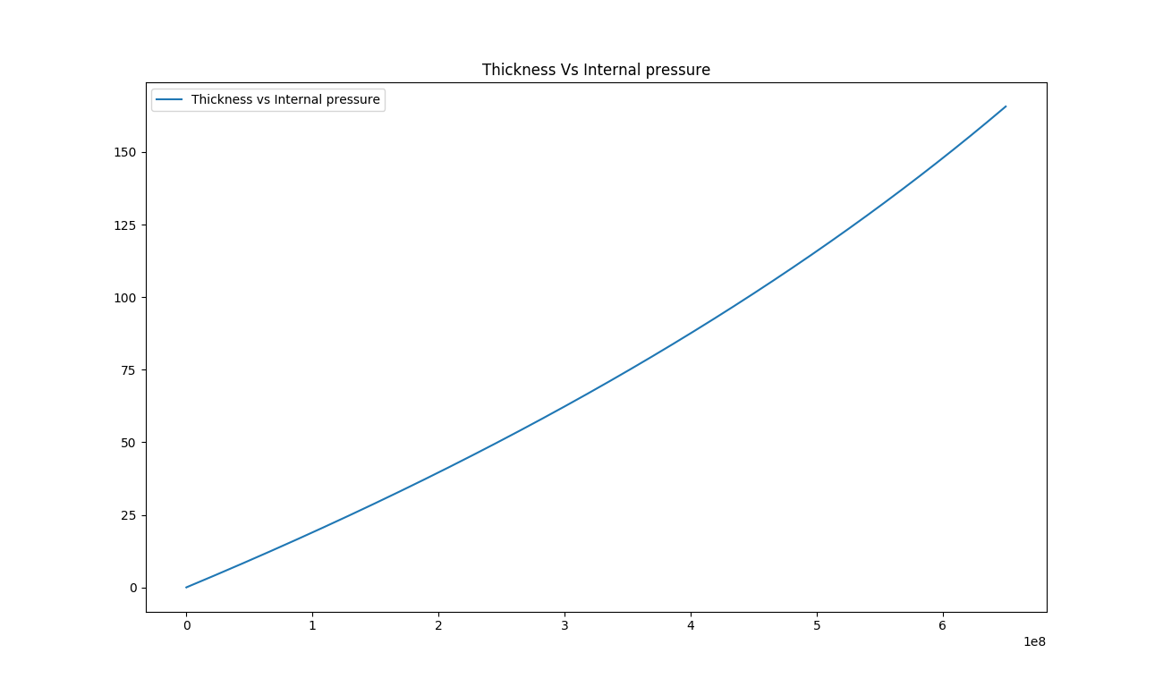

*Fig 1.2 Thickness against Internal pressure*

This shows that the relation between the internal pressure and the thickness of cylinder is linear. From the computation, it is also obtained that internal pressure of the cylinder for a factor of safety 3 is 650.042MPa. and thickness 42.075mm as shown below:

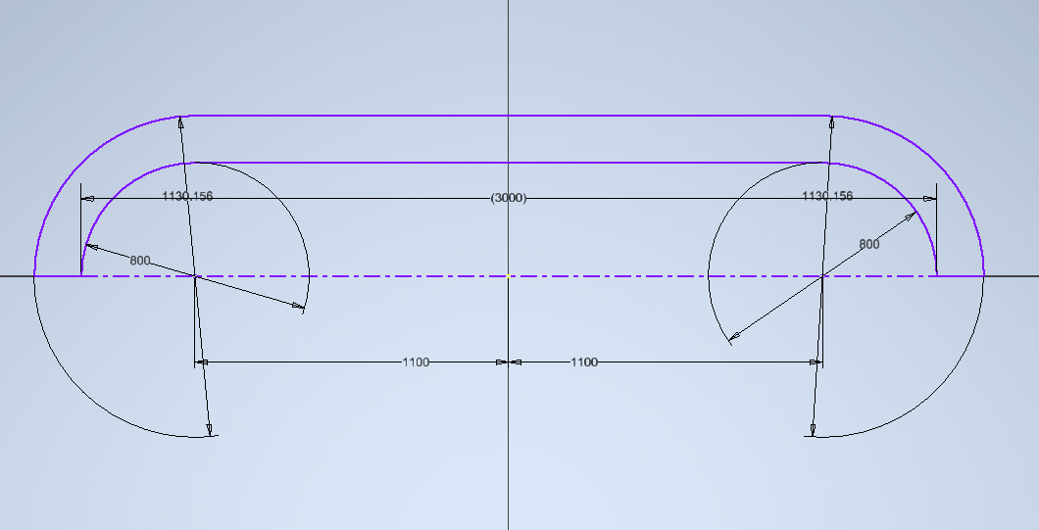

*Fig 1.3 Actual dimensions of the cylinder*

Heating coil modeling and tube

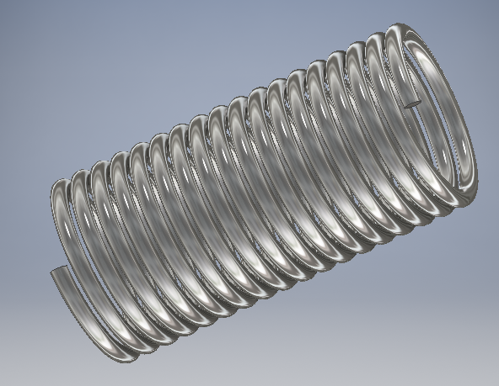

*Fig 1.4 Heating coil*

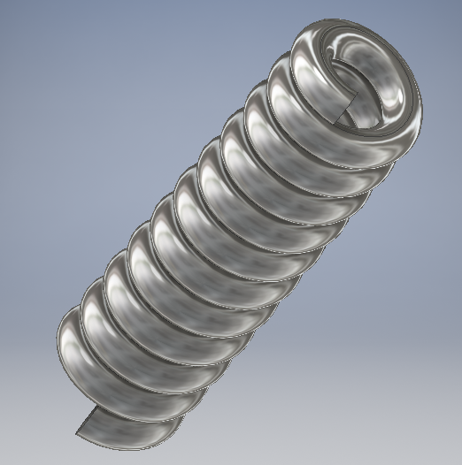

*Fig 1.5 Tube*

**Heating Element Design Calculations (Round Wire Element)**

Notations:

V = Voltage (Volts)

W = Power (Watts)

S = Surface area loading (W/cm2)

Rt =Element Resistance at operating temperature (Ohms)

R = Element resistance at 200C

F = Temperature resistance factor

L = Length of the wire (m)

A = resistance per meter (Ohms/m)

**Calculations:**

1. To calculate the wire diameter and length required for a 750w/240v tube, operating at a maximum temperature of 1100°C, the total resistance of the element at operating temperature (Rt) will be:

$$R_{t}=\frac{V^{2}}{W}$$

= $\frac{{240}^{2}}{750}=76.8 Ohms$

1. Using [specific heating element alloy wire](https://www.jlcelectromet.com/nickel-chromium-heating-resistance-alloy-grades.html), find the Temperature Resistance Factor at C°C operating temperature as F thus the total resistance of the element at 20°C (R) will be.

$$R_{t}=\frac{R_{t}}{F}$$

Using RW80 wire, the [Temperature Resistance Factor (F)](https://www.alloywire.co.za/electrical-resistance-wire-hot-cutting-wire/heating-element-design/overview-heating-element-design-calculation/) at 1100°C is 1.071 thus the total resistance of the element at 20°C (R) will be:

$$R_{t}=\frac{76.8}{1.071}=71.71 Ohms$$

1. Knowing the dimensions of the tube, the length of wire that may be wound round it may be estimated.  Thus, the resistance required per meter of wire will be:

For example a length of wire of 9 meters

$$A=\frac{R}{L}$$

= $\frac{71.71}{9}=7.97Ohms/m$

Find the [heating element wire of standard wire diameter](https://www.jlcelectromet.com/fecral-heating-resistance-alloy-grades.html) which has a resistance per meter which is closest to A.

 RW80 of wire diameter 0.417mm has a resistance per meter of 7.91 ohms/m which is closest to 7.97 ohms/m.

The actual wire length (L):

$$L=\frac{R}{A}$$

= $\frac{71.71}{7.91}=9.066m$

A change in [heating element wire length](https://www.jlcelectromet.com/fecral-heating-resistance-alloy-grades.html)may mean adding or subtracting the pitch of the wire to achieve the total resistance value required.

The surface area loading (S):

$$S=\frac{W}{l*d*31.416}$$

= $\frac{750}{7.066*0.417*31.416}=6.31W/cm2$

The surface area loading can be higher or lower if it is considered the heat transfer be better or worse, or depending upon the importance of the [heating elements life](https://www.jlcelectromet.com/fecral-heating-resistance-alloy-grades.html).

Therefore, for the design of a heating coil to handle 750w and 240V working over a length of 9m, then from our analysis the coil has to have total resistance 71.71 Ohms with a surface are loading of 6.31W/cm2. Besides, the coil should have a diameter of 0.147mm for maximum heat transfer.

Material

The material use in the manufacture of the heating coil should be in tandem with the following objectives.

1. High electrical resistance
2. Corrosion resistance at high temperatures
3. High melting points

The material that we choose for the manufacture of the heating coil was an alloy of nickel and chromium. Nickel Chromium has a percentage of nickel and chromium combined. The addition of the chromium provides an increase of electrical resistance as well as corrosion resistance to high temperatures, making the alloy appropriate for wound wire elements due to its ductility and strength. This alloy has a maximum operating temperature of 1100°C and a heat capacity of about 20°C

Burner

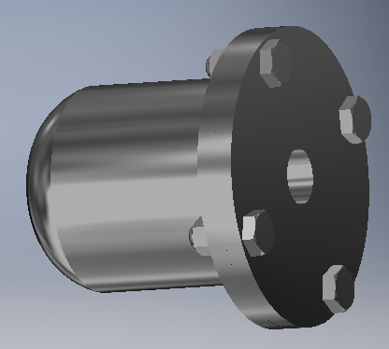

Fig 1.5 Burners

The materials chosen for the manufacture of these burners are made from silicon carbide. This is so since silicon carbide has high heating temperature, high temperature resistance, oxidation resistance, corrosion resistance, and long service life. Besides it has the characteristics of fast heating, small high temperature deformation, convenient installation and maintenance, and has good chemical stability. It is convenient, safe and reliable to use the silicon carbide rod for heating. The resistance is accurate and adopts Secondary resistance measurement; resistance error is small. The silicon carbide rod has high density, strong conductivity, fast heating, low power consumption, thereby saving energy and reducing consumption and reducing production costs.

Atomizer

An atomizer is required to deliver the pressurized oil under high pressure to the combustion unit in a tiniest sprays possible. There are three viable designs for the atomizer: coaxial swirl injector, pintle injector and self-impinging injector. From the abovedesigns the coaxial swirl injector was selected due its ease of fabrication compared to the pintle injector and self-impinging injector. The injectoris expected to deliver the pressurized oil with ideal flow characteristics and atomize the fuel adequately.

Coaxial Swirl Injector

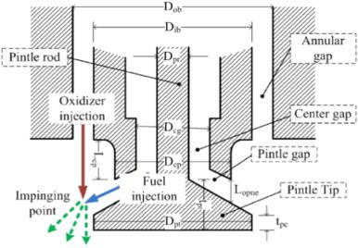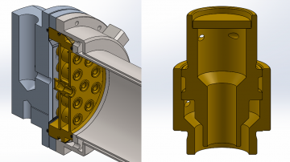

*Fig 1,1 Coaxial Swirl Injector*

Coaxial swirl injector performs the primary function of feeding oil to the combustion chamber. The design of this injector for oil furnace meets the following functional requirements;

1. The oil injector must be able to inject oil into the combustion chamber at the correct ratio and correct flow rates. For this reason the discharge coefficient of the injector must be determinable.
2. The oil injector should ensure complete mixing of oil with air to avoid undesired combustion with might result in the emission of carbon monoxide.
3. The oil injector must facilitate a primary pressure drop of between 10-20% to prevent discharged oil from flowing back into the injection system and causing an explosion.

Design

This swirl injector will consist of two primary parts; the inner element and the outer element. The two elements are placed on different levels separated by a separator plate. The inner element takes in pressurized oil tangentially which causes the liquid to swirl along the wall of the inner section. The pressurized oil enters the outer section tangentially as well and swirls along the wall of the outer element. This results in the pressurized air leaving the inner element in the shape of a cone which collides with the cone formed by the outer element. In this way the pressurized oil and pressurized air each leave each of the elements in a cylindrical manner colliding and atomizing due to the high pressure and velocity of the flow. The configuration is as displayed in figure 1.

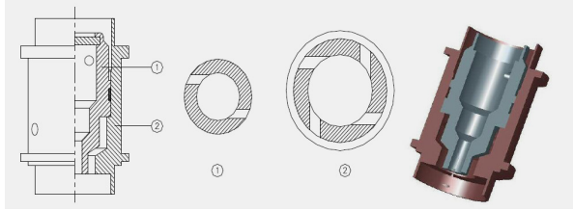

*Fig 1.2 Swirl Injector Exploded View*

This configuration meets the functional requirements of any fuel injector system .The efficiency of the injector for oil of any density can reach as high as 95%. The swirl injector has the following advantages;

1. The design is highly scalable since the assembly can be made bigger by adding the number of swirl elements in the assembly.
2. The swirl and assembly are relatively easy to machine
3. The swirl offers high atomization which is crucial for the conversion of chemical energy to thermal energy
4. The swirl element offers adjustable flow parameters allowing the assembly to create oxygen rich zones and oil rich zones.
5. Swirl elements offer the ability to vary the velocity of the fuel which can enhance the mixing of the pressurized air and pressurized oil.

The disadvantages of swirl injectors are:

1. They are a relatively new type of injector with fewer developed optimization characteristics
2. They require high dimensional accuracy for high performance

The other types of injector designs considered were;

Assembly and Fabrication

The development of the design was done by separating the assembly into five distinct parts:

1. Separator plate
2. Base plate
3. Swirler cap
4. Inner swirl element
5. Outer swirler element

**Swirl Assembly**

The parts were drawn on Autodesk Inventor for the 3D representation. The individual parts were then assembled. A cross section of the assembly is shown below.

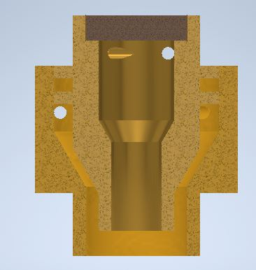

*Fig 1.3 Cross section of the assembly*

MasterCAMwas then used to show the fabrication processes.

The cap was machined using a CNC lathe. The first process was facing the stock. This was followed by a rough surface turning on the outer diameter profile followed by a finishing process on the surface. The part was then cut off from the stock using a grooving tool. The tool paths are shown below:

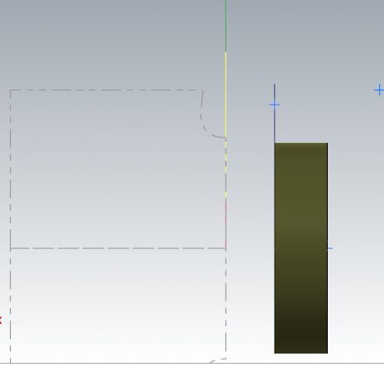

*Fig 1.4 Cap Machining*

The inner element was machined using a CNC lathe. The first process was facing using a right hand turning tool. A rough turning operation was then used to bring the dimensions to closer tolerance of the desired profile. A grooving operation was then used to machine the flanges on the profile. A grooving tool was also used to finish the tapered turning on the end of the part. A finishing turning operation was then done to bring the part to the required dimensions. A diameter 4 drill was then used to drill through the entire part. A diameter 8 drill was then used to a depth of 9mm. An internal grooving tool is then used to finalize the internal profile. The part was then cut off from the stock using a grooving tool. The holes were machined using a five axis milling machine. The figure below some of the generated tool paths.

~~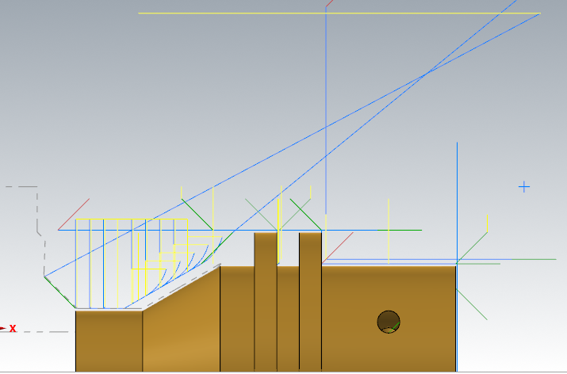~~

*Fig 1.5 Inner element of the swirler*

The outer element was machined using a CNC lathe. The first process was facing. This was followed by a rough turning operation on the profile. A grooving tool was then used to machine the end on the profile where there is a diameter change. The outer element was then finalized with a finishing turning operation. For the internal profile a drill of diameter 8 is passed through the entire stock. THisis followed by a drilling with a 12 mm drill to a depth of 12.12mm. The internal profile is then finalized by an internal turning operation. The part was then cut off from the stock using a grooving tool. The holes were machined using a 5 axis milling machine.

~~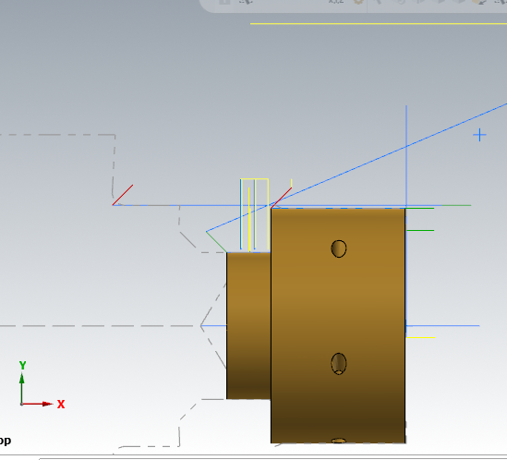~~

*Fig 1.6 Outer element of the swirler*

**Base plate**

The stock of this part was as defined:

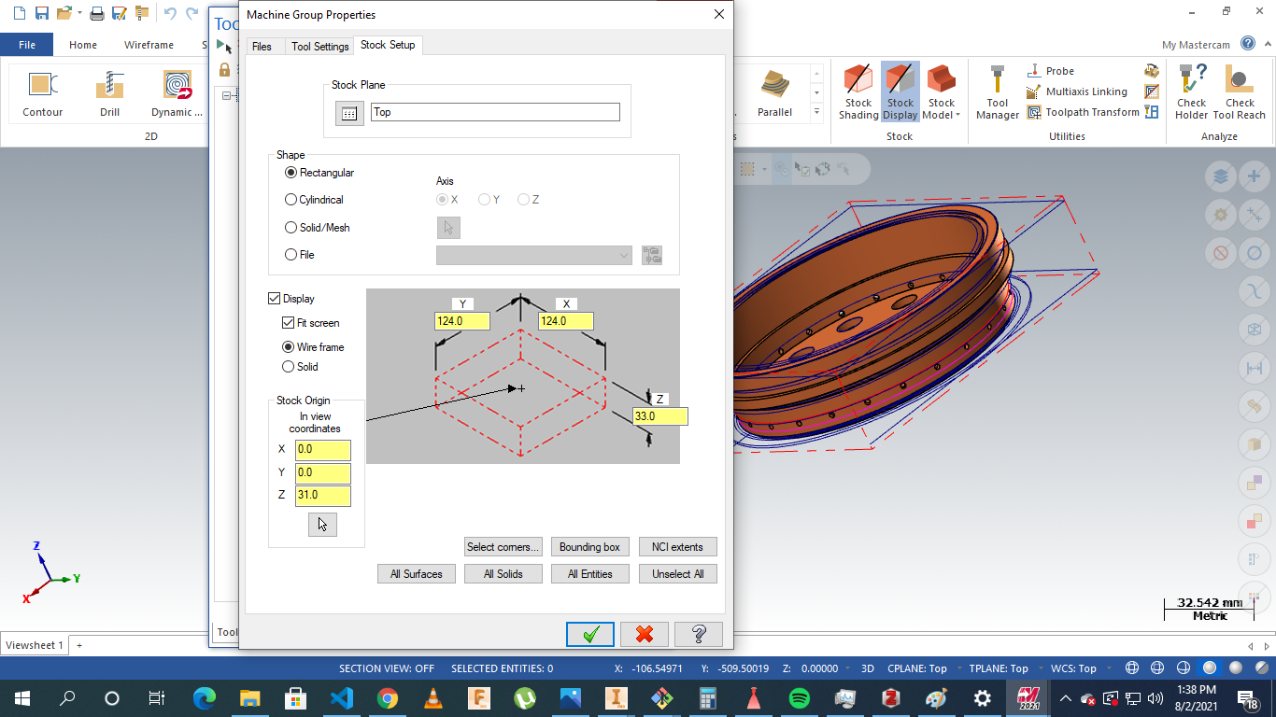

*Fig 1.7 Base plate machining*

The operations were to conducted on a five axis milling. The processes involved include: facing, contour milling drilling slot milling and multi-axis drilling.

The parts were milled as the material to be used was brass.

Operations are highlighted below:

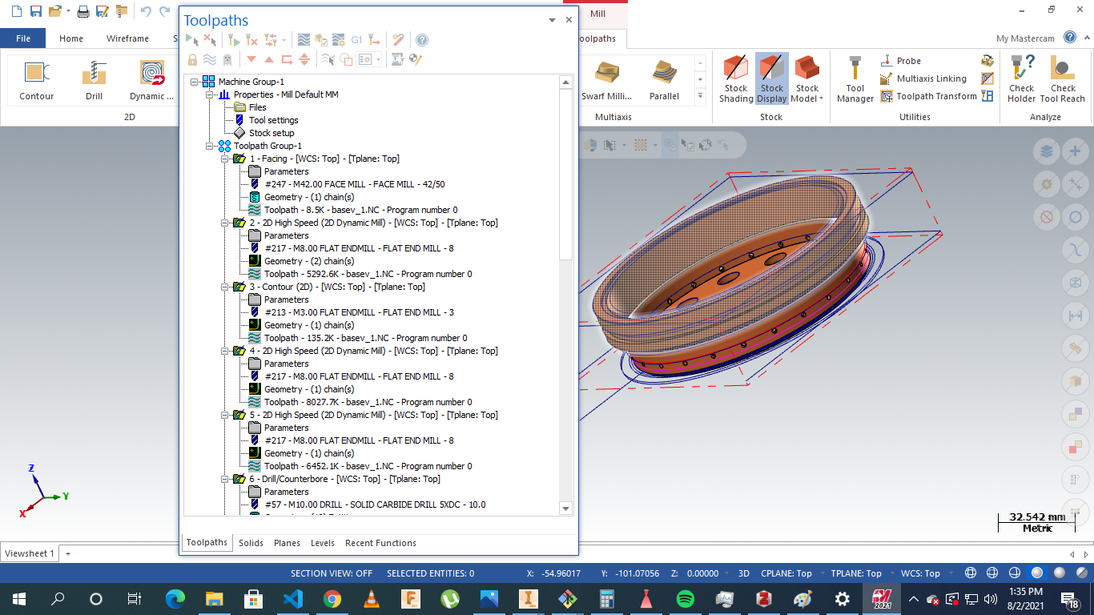

*Fig 1.8 Base Plate total operations*

**Separator plate**

The stock was as defined:

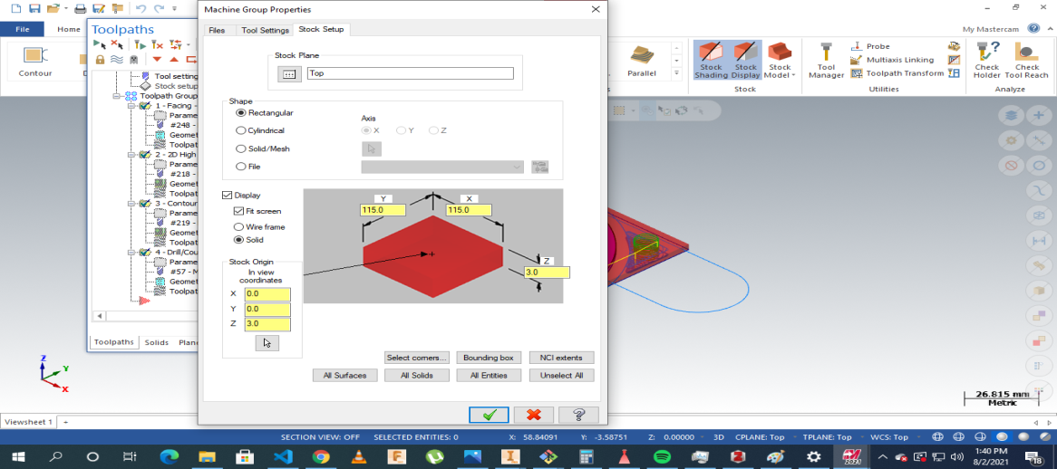

*Fig 1.9 Separator plate stock Setup*

The operations involved: facing, drilling,contouring and parting.

The processes were as displayed :

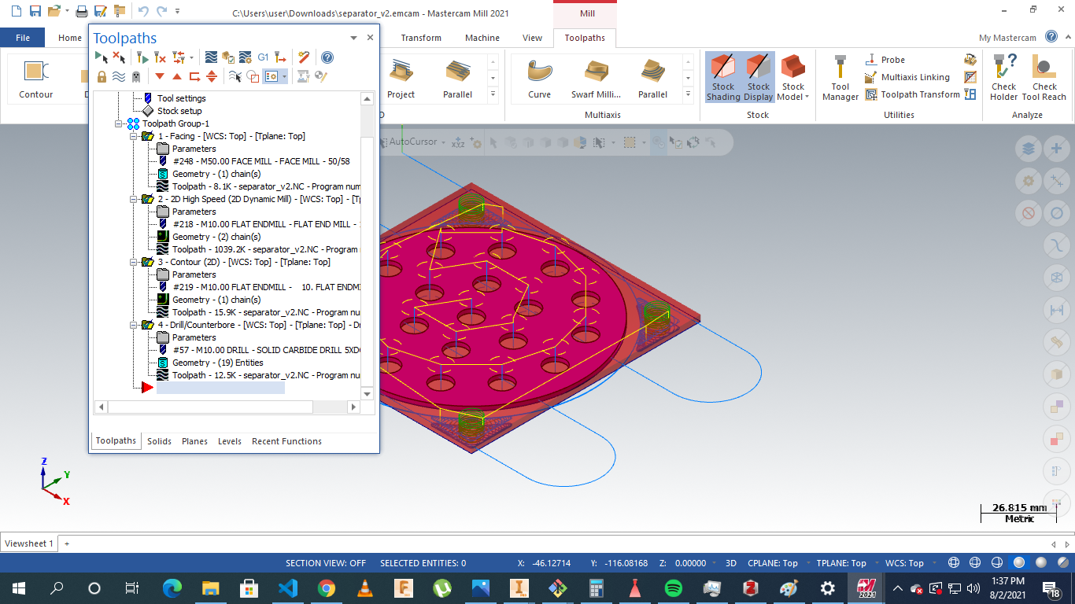

*Fig 2.0 Stock Plate Machining Instructions*

# 

References

[L.-J. Yang and Q.-F. Fu, ‘Theoretical Investigation on the Dynamics of a Gas-Liquid Coaxial Swirl Injector’, *J. Propuls. Power*, vol. 27, no. 1, pp. 144–150, 2011.](https://www.zotero.org/google-docs/?tOBzsF)

H. Belal, A. Makled, and M. Al-Sanabawy, “Vaporization-controlled simplified model for liquid propellant rocket engine combustion chamber design,” IOP Conference Series: Materials Science and Engineering, vol. 610, p. 012088, Oct. 2019, doi: 10.1088/1757-899X/610/1/012088.

Edge, E. (2021). Clavarinos equation thick-walled cylinders of ductile material Calculator and formula. Retrieved 7 August 2021, from <https://www.engineersedge.com/calculators/clavarinos_equation_thickwalled_cylinders_15620.htm>